Computer networks I and insight into industry, 2nd lab assignment

Student name, ID number: | Maksims Gudima , mg21003

The results of each task must be written in this document, then saved and sent as attachment to the teachers e-mail address leo.truksans@lu.lv with subject line “Lab2 results” together with your full name, surname and student ID.
Notes:
- Where a placeholder “Picture:” is written, insert a screenshot that clearly demonstrates the result of that task. Try cutting off unnecessary parts of picture so that only the actual result is demonstrated.
- This lab assignment is intended to be done in a network that assigns IP settings automatically (DHCP) and there are no limits to set different IP address. If settings are already static, consult network administrator which different IP address you may choose.
- Network card parameters can be checked in command line: ipconfig /all (Windows), ip a (Linux).
- To change network settings of the Windows operating system step through following windows: Control Panel, Network Sharing Center, Change adapter settings, press right mouse button on the NIC, then Properties, Local Area Connection Properties, Internet Protocol Version 4 (TCP/IPv4) Properties.
- To change network settings of the Linux operating system press on the icons in top right corner, choose Settings, Network settings.
- Wireshark program can be downloaded and installed from https://www.wireshark.org/#download.
- In Wireshark main window double-click network card to start capturing packets.
- You can look up the three letter city codes in the https://www.iata.org/en/publications/directories/code-search/ frame “Search Location Codes”.
- You can look up NIC manufacturer UOI codes in http://standards-oui.ieee.org/oui.txt .
- Each task can score up to 10 points. If all tasks are completely done 15 minutes before assignment time out, you will receive 10 more points.

Tasks:
- With Wireshark program capture the process of pinging ping.lv server, e.g.: ping ping.lv. Find at least 6 packets that correspond to the ping process. By what criteria can you distinguish them from others?

We can distinguish them by desination and source ip .They have specific colour – pink (protocol ICMP)

Picture:
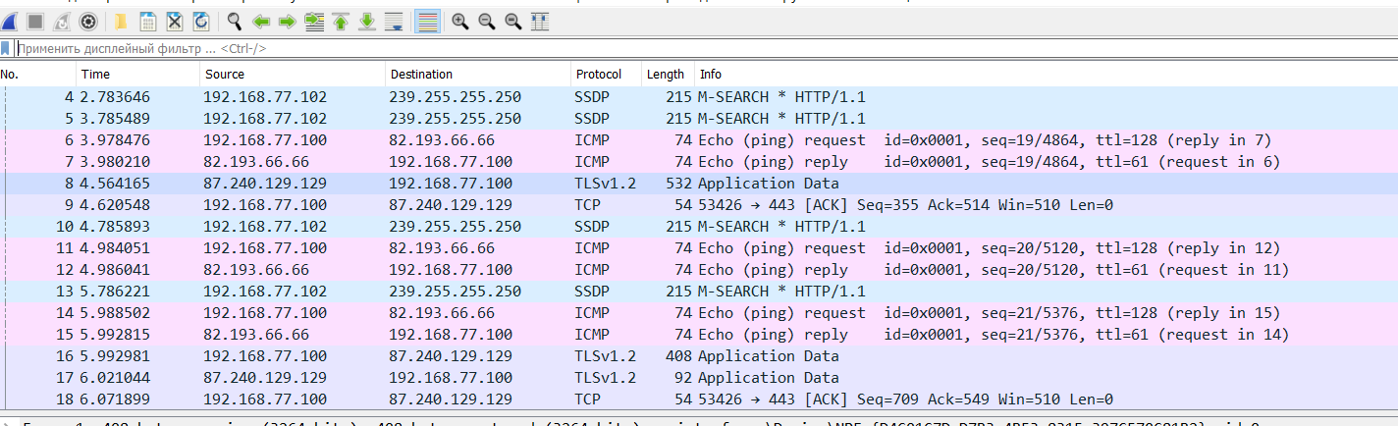
- What was the ping reply statistics in previous task:
  - How many requests were sent: ___4____________
  - How many replies were received: ___4____________
  - What was the TTL of replies: ____61___________
  - How much round trip time (RTT) was:
    - for fastest reply: ______1___ms____
    - arithmetically average: ____2__ms______
    - slowest reply: _______4 ms______

- With Wireshark program capture the tracert process to apnic.com server. Find at least 4 packets corresponding to the process. By what criteria can you distinguish them from others?

We can distinguish them by desination ip

Picture: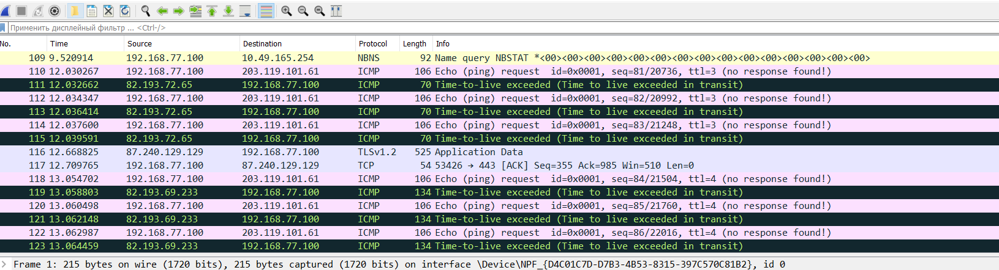

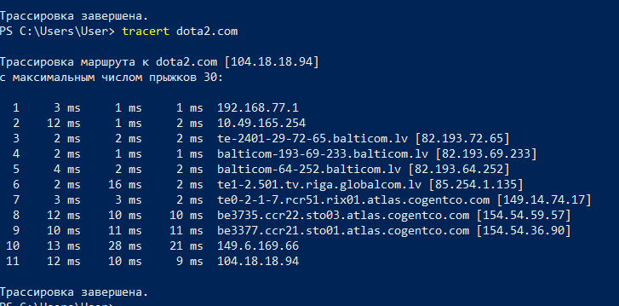
- What geographic locations can you see in the previous tracert process?

Latvia(Riga)
Estonia(Tallinn)
Sweden(Stocholm)
Denmark(Kopenhagen)
USA(Piscataway)
USA(Ashburn)
USA(Los Angeles)
Australia(Sydney)

- Run tracert to another server of your choice. What geographic locations can you see?

Tracert dota2.com

Latvia(Riga)
Sweden(Stockholm)
USA(San Francisco)

- Find out computer’s IPv4 and IPv6 settings (check the “Connection information”):
  - IPv4 address: __192.168.77.100___________________
  - Mask: _____255.255.255.0_____________________
  - Gateway: _____192.168.77.1__________________
  - DNS server: _____82.193.64.2________________
  - IPv6 address: fe80::4892:298f:c598:6acb%18_______
Picture:
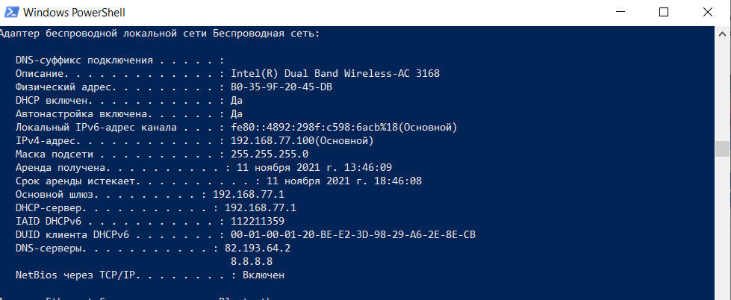

- Set static IPv4 settings, that slightly differ from the automatic ones:
  - IP address – the first 3 parts are the same, the fourth chosen different (prior to this discover with ping that it is not used yet);
  - Mask, Gateway and DNS server are as they were;
  - ... and again show ping packets to www.lu.lv server captured by Wireshark. Does the computer use the new IPv4 address? Where do you see it?

I can see that source ip has changed

Picture:
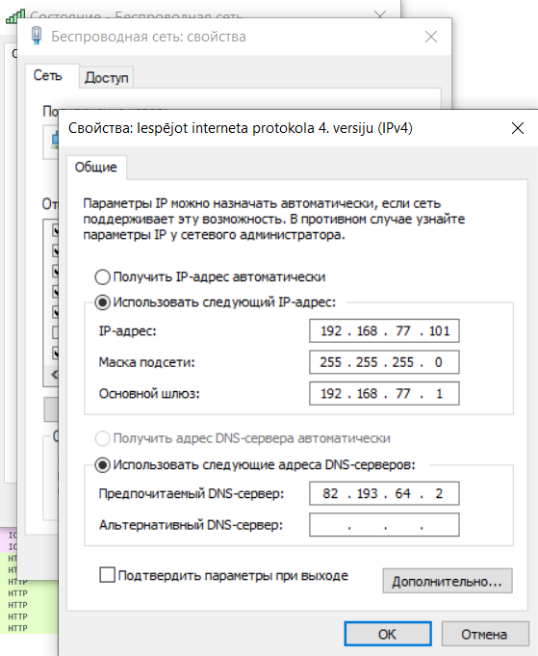
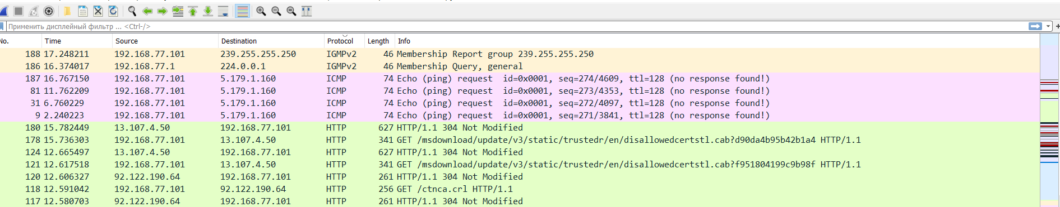

- Find out computer’s MAC address and that of the gateway.
  - What is computer’s MAC: ___B0-35-9F-20-45-DB________________
  - From it’s OUI find out it’s manufacturer: _____Intel Corporate______________

  - What is gateway’s MAC: ___ec-08-6b-2b-ca-10________________
  - From it’s OUI find out it’s manufacturer: _____TP-LINK TECHNOLOGIES CO.,LTD______________

- With Wireshark program capture the ARP process. You can enforce that by removing the gateway’s IP address from ARP cache (arp -d <IP_addrress>). Find both packets that correspond to the process. By what criteria can you distinguish them from others?

Filtered by the name ARP

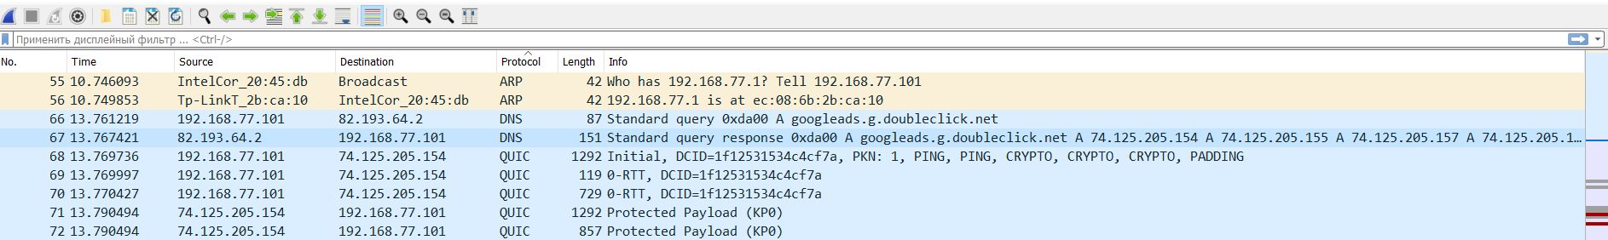
After finishing this assignment set computer’s IPv4 settings back to the ones before task 7 and check that computer gets the same IP settings that you found in task 6.

